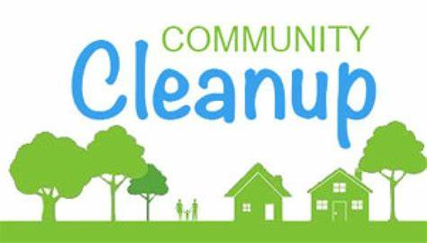

Showing Pride City Wide
Friday May 22nd 8am to 4pm
Saturday May 23rd 9am to 2pm
Drop off location - 73 West State Street (Electric Dept. Lot)
We are encouraging ALL RESIDENTS to use this opportunity to take part in our annual community clean-up! By cleaning your yard, you help control pests, like rodents and mosquitoes which spread disease.

Please bring the following items from the EXTERIOR of your property:
(NO curbside pick-up service provided)

- Appliances: stoves, refrigerators, window air conditioners, washers and dryers
- Furniture that is around the EXTERIOR of your property (no mattresses)
- Passenger Vehicle Tires that are NOT ON RIMS
- Fallen limbs/branches less than 2 inches in diameter
(fresh-cut limbs will NOT be accepted)

ITEMS NOT ACCEPTED:

- Pesticides, Herbicides, Cleaners
- Electronics: TVs and Computers
- Hazardous Waste: Paints, Stains, Varnishes, Oils, Fluids, and Batteries
- Commercial/Business, Tractor, Race, or Semi Tires

*Dried latex paint can be accepted
(Leave the lid off to speed up the drying process)

Please note this is for Shelby City Residences only

Please note the Shelby City Health Department reserves the right to refuse any material deemed unfit for this collection.

Please see back side for Electronic Recycling Event information which will be held on
Saturday May 23rd 10 Am – 2 PM

